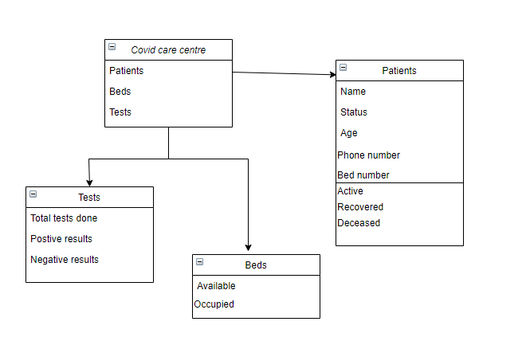

**Structural diagram for Covid centre Database Management System**